
FACULITY OF INFORMATION AND COMMUNICATION TECHNOLOGY

PROG 102: PRINCIPLES OF SOFTWARE ENGINEERING
ASSIGNMENT TITTLE: FINAL PROJECT
DUE DATE: WEEK 10
LECTURER: MR. SANTIGIE FODAY KAMARA
CLASS: BSEM1203F
SEMESTER/YEAR: SEMESTER 2/ YEAR 1
Academic Honesty Policy Statement

We, hereby attest that contents of this attachment are my own work. Referenced works, articles, art, programs, papers or parts thereof are acknowledged at the end of this paper. This includes data excerpted from CD-ROMs, the internet, other private networks, and other people’s disk of the computer system.

NO | NAMES | ID NUMBER | SIGNATURE
1 | Gleekan David Williams | 905005907
2 | Ziad Mohamed Elgabry | 905005887
3 | Hashiatu Nyallay | 905005936

Student’s Signatures: Date:

MENTOR’S COMMENTS/GRADE:

for office use only upon
receiving
Remark
DATE :
TIME :
RECEIVER’S NAME:

Table of Contents
INTRODUCTION 3
1.1 Background 3
1.2 Problem Statement 3
1.3 Aim 3
1.4 Objectives 4
SOFTWARE DEVELOPMENT LIFE CYCLE 5
2.1 Selected SDLC Model 5
2.2 Requirements Phase 5
2.3 Design Phase 5
2.4 Development Phase 5
2.5 Testing Phase 5
2.6 Deployment Phase 5
2.7 Maintenance Phase 5
SYSTEM ARCHITECTURE DESIGN 6
3.1 Architecture Overview 6
Presentation Layer 6
Business Logic Layer 6
Data Layer 6
3.2 Architecture Diagram 6
3.3 Component Interaction 7
SYSTEM ANALYSIS 8
4.1 Existing System 8
4.2 Problems Identified 8
4.3 MVP 2 Validation 8
4.4 Findings 8
What Worked 8
Limitations 9
PROTOTYPE DEVELOPMENT 10
5.1 Prototype Tool 10
5.2 Key Screens 10
5.3 Design Principles 11
GIT AND GITHUB INTEGRATION 12
6.1 Purpose of GitHub 12
6.2 Repository Contents 12
PROJECT MANAGEMENT 13
7.1 Gantt Chart 13
7.2 Network Diagram 14
LICENSE, DESIGN QUALITY AND SDG RELEVANCE 15
8.1 License Selection 15
8.2 Design Quality 15
8.3 SDG Alignment 15
CONCLUSION 16
REFERENCES 17

INTRODUCTION

1.1 Background
Access to suitable rental accommodation remains a significant challenge in many urban communities. Prospective tenants often spend considerable time searching for properties that meet their requirements, while landlords and property agents struggle to identify suitable tenants efficiently. The rental process frequently relies on social media advertisements, personal referrals, and phone calls, resulting in fragmented information and slow communication.
Digital technologies provide opportunities to improve the rental housing process through centralized information management and automated matching systems. RentSure is proposed as a Digital Public Good that connects tenants, landlords, and property agents through a web-based platform. The system enables tenants to submit accommodation requirements and allows landlords or agents to publish available properties. A matching mechanism then recommends suitable properties based on user requirements.

1.2 Problem Statement
The current rental housing process faces several challenges:
- Difficulty locating suitable accommodation.
- Lack of centralized housing information.
- Time-consuming manual matching.
- Inefficient communication between tenants and landlords.
- Limited transparency in the rental process.
These issues increase the time and effort required to secure accommodation.

1.3 Aim
The aim of this project is to design a Digital Public Good that improves the rental housing process through automated tenant-property matching.

1.4 Objectives
The objectives of the project are:
- To create a platform for tenants and landlords.
- To automate tenant-property matching.
- To improve housing accessibility.
- To reduce rental search time.
- To demonstrate software engineering principles.
- To support Sustainable Development Goal 11.

SOFTWARE DEVELOPMENT LIFE CYCLE

2.1 Selected SDLC Model
The Agile Software Development Life Cycle was selected for the development of RentSure. Agile supports iterative development, continuous improvement, and rapid feedback.

2.2 Requirements Phase
Requirements were gathered through observation of existing rental practices and analysis of MVP 2 validation findings. Key requirements included user authentication, requirement management, property listing management, and matching functionality.

2.3 Design Phase
The design phase involved:
- User interface design using Figma.
- System architecture design.
- Database planning.
- Matching workflow design.

2.4 Development Phase
Development was divided into multiple iterations. MVP 2 validated the matching concept using Local Storage, while MVP 3 extends the system with authentication and database support.

2.5 Testing Phase
Testing focused on:
- Navigation functionality.
- CRUD operations.
- Matching logic.
- Data persistence.

2.6 Deployment Phase
The final solution is intended to be deployed as a web application accessible through mobile and desktop browsers.

2.7 Maintenance Phase
Future improvements include messaging, push notifications, and AI-assisted recommendations.

SYSTEM ARCHITECTURE DESIGN

3.1 Architecture Overview
RentSure follows a three-tier architecture.

Presentation Layer
The presentation layer consists of mobile-friendly web interfaces used by tenants and landlords.

Business Logic Layer
The business logic layer handles:
- User authentication
- Property management
- Requirement management
- Matching calculations

Data Layer
The data layer stores users, properties, requirements, and match results in a MySQL database.

3.2 Architecture Diagram

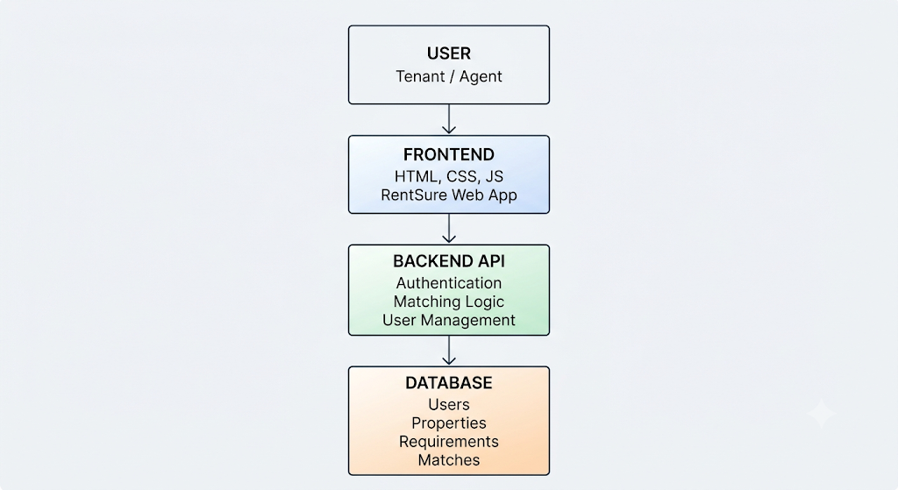

3.3 Component Interaction
A tenant creates a housing requirement. The matching engine compares the requirement against available properties and generates compatibility scores. Matching results are then displayed to the user through the web interface.

SYSTEM ANALYSIS

4.1 Existing System
Current rental processes commonly rely on:
- Social media advertisements
- Phone calls
- Personal referrals
- Physical property visits

4.2 Problems Identified
Major limitations include:
- Slow communication
- Inaccurate information
- Manual matching
- Lack of centralized records

4.3 MVP 2 Validation
A preliminary MVP 2 prototype was developed to validate the matching concept.
Features included:
- Tenant management
- Property management
- Matching engine
- Local Storage persistence

4.4 Findings

What Worked
- Matching recommendations were useful.
- Navigation was simple.
- Data entry workflows were straightforward.

Limitations
- Single-user operation
- No authentication
- No centralized database
- Not suitable for deployment
These findings informed the design of MVP 3.

PROTOTYPE DEVELOPMENT

5.1 Prototype Tool
Figma was used to design the user interface.

5.2 Key Screens
The prototype includes:
- Welcome Screen
- Login Screen
- Registration Screen
- Tenant Dashboard
- Matching Properties
- Property Details
- Create Requirement
- Agent Dashboard
- Create Property
- Profile Screen
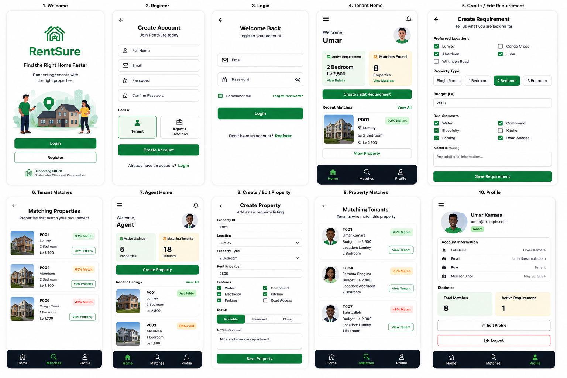

5.3 Design Principles
The interface follows mobile-first design principles:
- Simplicity
- Consistency
- Accessibility
- Easy navigation

GIT AND GITHUB INTEGRATION

6.1 Purpose of GitHub
GitHub was used for:
- Version control
- Project backup
- Documentation management
- Collaboration

6.2 Repository Contents
The repository contains:
- Source code
- Project documentation
- Diagrams
- Prototype assets

PROJECT MANAGEMENT

7.1 Gantt Chart
ID | Activity | Duration (Days) | Dependency
A | Requirements Analysis & MVP2 Review | 3 Days | None
B | Research & SDG Alignment | 2 Days | Requirements
C | System Design (Use Cases, UML, Database) | 4 Days | Research
D | Architecture & Prototype Design (Figma) | 3 Days | System Design
E | MVP3 Frontend Development | 5 Days | Prototype Design
F | MVP3 Backend & Database Development | 5 Days | Frontend Development
G | Testing & Validation | 3 Days | Backend Development
H | Documentation, GitHub & Final Submission | 3 Days | Testing
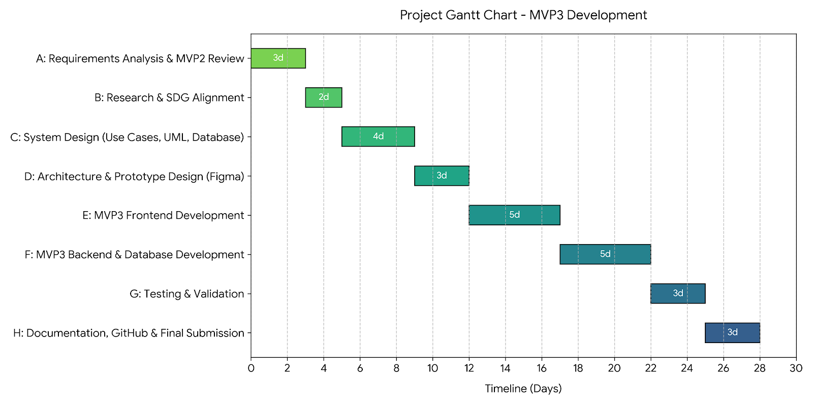

7.2 Network Diagram
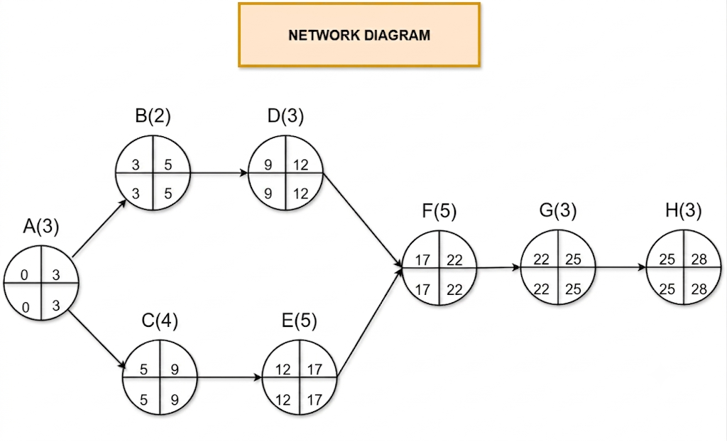

LICENSE, DESIGN QUALITY AND SDG RELEVANCE

8.1 License Selection
The MIT License was selected because it promotes open-source collaboration while remaining easy to understand and implement.

8.2 Design Quality
The user interface was designed using mobile-first principles and emphasizes simplicity, consistency, and usability.

8.3 SDG Alignment
RentSure supports Sustainable Development Goal 11: Sustainable Cities and Communities.
The system contributes by:
- Improving access to housing information.
- Reducing rental search time.
- Increasing transparency in housing markets.
- Supporting digital transformation.

CONCLUSION
RentSure is a Digital Public Good designed to improve the rental housing process through automated tenant-property matching. The project demonstrates the application of software engineering principles including Agile development, system architecture design, prototyping, project management, and version control.
Validation through MVP 2 confirmed the usefulness of the matching concept and informed the design of MVP 3. The proposed system provides a foundation for improving housing accessibility while contributing to Sustainable Development Goal 11.
Future enhancements may include real-time messaging, push notifications, and AI-assisted recommendations.

REFERENCES
- PROG102 Principles of Software Engineering Lecture Notes, 2026.
- Agile Alliance Documentation.
- Figma Documentation.
- GitHub Documentation.
- United Nations Sustainable Development Goals.

